BYTEWISE FELLOWSHIP PROGRAM

DATA ENGINEERING

Tehreem Fatima

**WEEK 2**

**21– March -2023**

***Task No 3***

***Write a few lines about these terms with examples:***

***• What is SQL?***

SQL - Structured Query Language is a programming language designed for managing and manipulating data in relational databases. It is used for tasks such as creating and modifying database structures, inserting, updating, and deleting data, and retrieving data for analysis and reporting.

***• What is DDL?***

DDL - Data Definition Language commands are used to define the structure of a database 1. Examples of DDL commands include CREATE, ALTER, and DROP. These commands allow you to create and modify tables, views, indexes, constraints, and other database objects.

***Example***

CREATE TABLE employees (

id int,

name varchar(255),

age int,

salary float

);

ALTER TABLE employees

ADD COLUMN department varchar(255);

DROP TABLE employees;

***• What is DML?***

DML - Data Manipulation Language commands are used to manipulate the data stored in the database. Examples of DML commands include SELECT, INSERT, UPDATE, and DELETE. These commands allow you to retrieve, add, modify, and delete data in the tables.

***Example***

INSERT INTO employees (id, name, age, salary, department)

VALUES (1, 'John Doe', 30, 50000, 'Sales');

UPDATE employees

SET salary = 60000

WHERE id = 1;

DELETE FROM employees

***• What is DQL?***

DQL - Data Query Language is a subset of SQL and refers specifically to the SELECT statement. This command is used to retrieve data from one or more tables in a database. With DQL, you can filter, sort, and group data retrieved from tables, and perform calculations and other operations on the data.

***Example***

SELECT name, age, salary

FROM employees

WHERE department = 'Marketing'

ORDER BY salary DESC;

***Task No 04***

***Practice about following in SSMS:***

***-Creating a Database.***

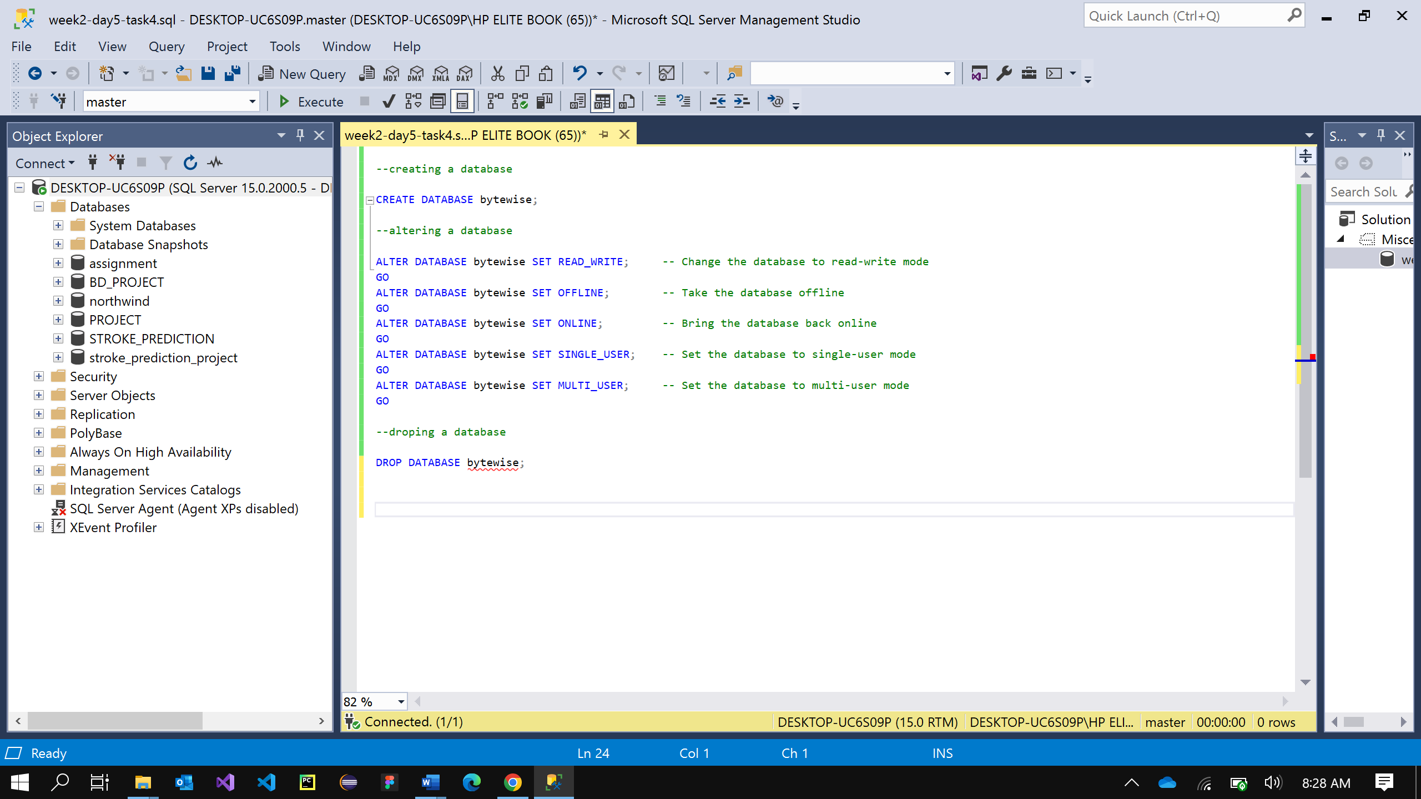

***-Altering a Database.***

***-Deleting a Database.***

